**Prehistoric Engineering Development**

The concept of engineering has existed since ancient times as humans devised fundamental inventions such as the pulley, lever, and wheel. Each of these inventions is consistent with the modern definition of engineering, exploiting basic mechanical principles to develop useful tools and objects.

The six classic simple machines were known in the ancient Near East. The wedge and the inclined plane or commonly known as ramp were known since prehistoric times. The wheel, along with the wheel and axle mechanism, was invented in during the 5th millennium BC. The lever mechanism first appeared around 5,000 years ago in the Near East, where it was used in a simple balance scale, and to move large objects. The lever was also used in the shadoof water-lifting device, the first crane machine, which appeared in Mesopotamia circa 3000 BC, and then in ancient Egyptian technology circa 2000 BC. The earliest evidence of pulleys date back to Mesopotamia in the early 2nd millennium BC, and ancient Egypt during the Twelfth Dynasty (1991-1802 BC).The screw, the last of the simple machines to be invented first appeared in Mesopotamia during the Neo-Assyrian period (911-609) BC. The Egyptian pyramids were built using three of the six simple machines, the inclined plane, the wedge, and the lever, to create structures like the Great Pyramid of Giza.

The earliest practical water-powered machines, the water wheel and watermill, first appeared in the Persian Empire, in what are now Iraq and Iran, by the early 4th century BC.

Ancient Greece developed machines both in the civilian and military domains. The Antikythera mechanism, an early known model of a mechanical analog computer, and the mechanical inventions of Archimedes, are examples of Greek mechanical engineering. Some of Archimedes' inventions, as well as the Antikythera mechanism, required sophisticated knowledge of differential gearing or epicyclic gearing, two key principles in machine theory that helped design the gear trains of the Industrial revolution and are still widely used today in diverse fields such as robotics and automotive engineering. Chinese and Roman armies employed complex military machines including the Ballista and catapult. In the Middle Ages, the Trebuchet was developed. In 132, polymath Zhang Heng invented the seismoscope for detecting earthquakes, which was not invented anywhere else in the world until 1,100 years later. Huan Tan's Xinlun is the earliest text to describe the trip hammer device powered by hydraulics (i.e., a waterwheel), which was used to pound and decorticate grain. 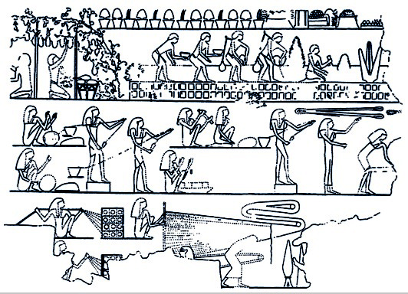 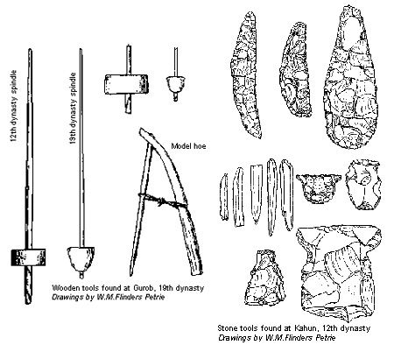

MEDIVAL ENGINEERING DEVELOPMENT

The earliest practical wind-powered machines, the windmill and wind pump, first appeared in the Muslim world during the Islamic Golden Age, in what are now Iran, Afghanistan, and Pakistan, by the 9th century AD. The earliest practical steam-powered machine was a steam jack steam turbine, described in 1551 by Taqi al-Din Muhammad ibn Ma'ruf in Ottoman Egypt.

The cotton gin was invented in India by the 6th century AD and the spinning wheel was invented in the Islamic world by the early 11th century, both of which were fundamental to the growth of the cotton industry. The spinning wheel was also a precursor to the spinning jenny, which was a key development during the early Industrial Revolution in the 18th century.

The crankshaft and camshaft were invented by Al-Jazari in Northern Mesopotamia circa 1206, and they later became central to modern machinery such as the steam engine, internal combustion engine and automatic controls. The earliest programmable machines were developed in the Muslim world. A music sequencer, a programmable musical instrument, was the earliest type of programmable machine. The first music sequencer was an automated flute player invented by the Banu Musa brothers, described in their Book of Ingenious Devices, in the 9th century. In 1206, Al-Jazari invented programmable automata/robots. He described four automaton musicians, including drummers operated by a programmable drum machine, where they could be made to play different rhythms and different drum patterns. The castle clock, a hydro powered mechanical astronomical clock invented by Al-Jazari, was the first programmable analog computer. Al-Jazari built five machines to pump water for the kings of the Turkish Artuqid dynasty and their palaces. Besides over 50 ingenious mechanical devices, Al-Jazari also developed and made innovations to segmental gears, mechanical controls, escapement mechanisms, clocks, robotics, and protocols for designing and manufacturing met

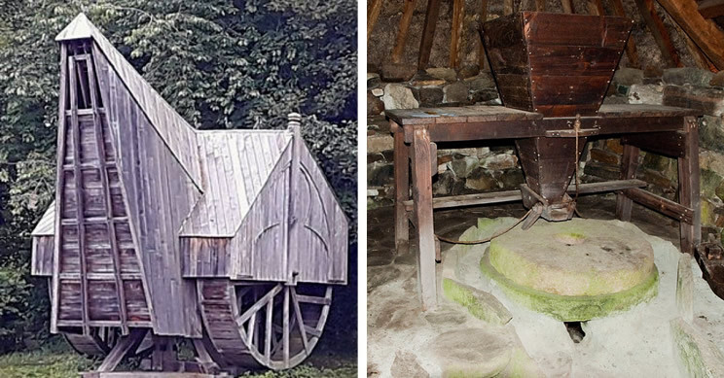hods

With the increased efficiency of the use of draught animals and new sources of power from wind and water, the middle ages saw something of an agricultural revolution. Crop yields boomed, allowing for farms to support ever-increasing populations. All thanks to the work and dedication of medieval engineers. This had a knock-on effect of helping fuel, both with mindpower and manpower, the further development of other industries around the continent.

MODERN ENGINEERING DEVELOPMENT

The inventions of Thomas Savery and the Scottish engineer James Watt gave rise to modern Mechanical Engineering. The development of specialized machines and their maintenance tools during the industrial revolution led to the rapid growth of Mechanical Engineering both in its birthplace Britain and abroad

The discipline of Electrical Engineering was shaped by the experiments of Alessandro Volta in the 19th century, the experiments of Michael Faraday, Georg Ohm and others and the invention of the electric motor in 1872. Electrical engineering became a profession late in the 19th century. Practitioners had created a global electric telegraph network and the first electrical engineering institutions to support the new discipline were founded in the UK and USA. Although it is impossible to precisely pinpoint a first electrical engineer, Francis Ronald’s stands ahead of the field, who created the first working electric telegraph system in 1816 and documented his vision of how the world could be transformed by electricity. The work of James Maxwell and Heinrich Hertz in the late 19th century gave rise to the field of Electronics. The later inventions of the vacuum tube and the transistor further accelerated the development of Electronics to such an extent that electrical and electronics engineers currently outnumber their colleagues of any other Engineering specialty.

Chemical Engineering, like its counterpart Mechanical Engineering, developed in the 19th century during the Industrial Revolution. Industrial scale manufacturing demanded new materials and new processes and by 1880 the need for large scale production of chemicals was such that a new industry was created, dedicated to the development and large scale manufacturing of chemicals in new industrial plants. The role of the chemical engineer was the design of these chemical plants and processes.

Aeronautical Engineering deals with aircraft design while Aerospace Engineering is a more modern term that expands the reach envelope of the discipline by including spacecraft design.[49] Its origins can be traced back to the aviation pioneers around the turn of the 20th century although the work of Sir George Cayley has recently been dated as being from the last decade of the 18th century. Early knowledge of aeronautical engineering was largely empirical with some concepts and skills imported from other branches of engineering. Only a decade after the successful flights by the Wright brothers, the 1920s saw extensive development of aeronautical engineering through development of World War I military aircraft. Meanwhile, research to provide fundamental background science continued by combining theoretical physics with experiments.

